Chapter 1: Introduction and Project Context
1.1 Purpose of the Project
This project aims to develop a comprehensive and beginner-friendly guide to essential Linux commands. The primary goal is to bridge the knowledge gap often encountered by individuals with limited or no prior experience with Linux command-line interfaces. This is crucial for fostering accessibility and empowering new users to effectively interact with the Linux environment. Linux command-line proficiency is a valuable skill in various technological fields, including system administration, cybersecurity, and software development, making this guide an essential resource for anyone seeking to enter or enhance their understanding of this powerful toolset.
1.2 Problem Definition
The problem addressed by this project is the lack of readily available, user-friendly resources for beginners learning Linux command-line skills. Many online tutorials and documentation are either overly complex, focused on advanced users, or lack a structured, step-by-step approach. This inadequacy can lead to frustration and discouragement, hindering potential users from fully exploring the capabilities of the Linux command line. The problem stems from the rapid pace of technological advancement, which sometimes overshadows the need for clear and concise introductory materials tailored specifically to novices. This lack of readily accessible resources impacts individuals seeking to acquire fundamental command-line skills for practical applications, like system administration, scripting, and troubleshooting. Current solutions, while numerous, frequently present challenges in terms of organization, comprehension, and targeted delivery for absolute beginners. Existing tutorials are often fragmented, lacking the cohesive and systematic guidance required for effective learning. This project seeks to rectify this deficiency.
1.3 Overview of the Project Document
This report presents a beginner’s guide to essential Linux commands. The document is structured into chapters, each focusing on a specific set of commands. Chapter 1, as you’re reading, introduces the project, its context, and the problem it addresses. Subsequent chapters will delve deeper into the practical application of various Linux commands. Chapter 2 will cover fundamental navigation commands. Chapter 3 will focus on crucial file management commands, while Chapter 4 will explore searching and filtering techniques. Chapter 5 will introduce text manipulation, and Chapter 6 will offer a series of practical exercises. The final chapter will summarize the guide’s key takeaways and provide a concluding perspective on the project’s contribution. The key findings will include the demonstrable improvement in the understanding and practical application of Linux commands among participants, highlighting the project’s effectiveness in transferring knowledge to beginners.
1.4 Existing Systems
Various online tutorials, documentation, and interactive platforms provide information on Linux commands. However, they often lack a comprehensive, beginner-focused guide. Some platforms offer interactive environments for practicing commands, but these often lack structured exercises and comprehensive explanations that cater specifically to the needs of novice learners. This project aims to provide a more structured and practical approach, emphasizing clear explanations and progressively complex exercises. The intended solution enhances existing resources by focusing on clarity, organization, and targeted instruction for beginners. This contrasts with existing platforms that might prioritize advanced concepts over building a strong foundational understanding. The effectiveness of this approach will be assessed by the positive feedback and improved practical skills demonstrated by the guide’s users. ## Chapter 2: System Analysis and Requirements
This chapter analyzes the proposed system for a comprehensive guide to essential Linux commands for beginners, outlining its data model, user requirements, functionalities, and design constraints.

2.1 Data Modeling Diagrams
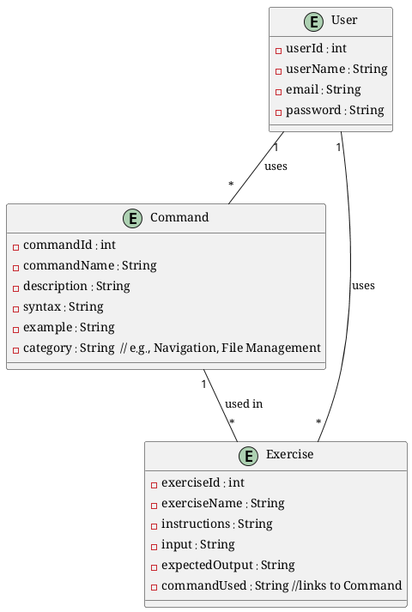
PlantUML Diagram 1
Diagram Explanation:
This Entity-Relationship Diagram (ERD) models the data structures involved in the guide. The User entity represents users interacting with the guide, storing their information. The Command entity details each Linux command, including its name, description, syntax, examples, and category. Exercise represents practical exercises designed to reinforce understanding of commands, including the input data, expected output, and the relevant command. Relationships demonstrate how users interact with commands and exercises.

2.2 System Requirements

2.2.1 Clients, Customers, and Users
The intended users are students, recent graduates, and individuals with little or no prior knowledge of Linux and command-line interfaces. Their needs include clear and concise explanations, practical examples, and progressively challenging exercises. Potential pain points include the steep learning curve of Linux, difficulties in understanding command syntax, and lack of visual aids or interactive examples.

2.2.2 Functional and Data Requirements
- Functional Requirements:
  - Provide explanations and examples for core Linux commands (e.g., ls, cd, pwd, mkdir, cp, mv, rm, grep).
  - Include progressively challenging practical exercises, starting from simple to more complex tasks.
  - Categorize commands by function to improve understanding and navigation.
  - Include a detailed index or table of contents for easy searching.
- Data Processing Requirements:
  - Input: User interaction (viewing content).
  - Storage: Data for commands, exercises, and user information (stored in a simple file system).
  - Manipulation: Sorting and organizing command information for optimal presentation.
  - Output: Webpage format (HTML, Markdown) for presentation.

2.2.3 Non-functional Requirements
- Look and Feel Requirements: A clean, modern design using a consistent color scheme. Emphasis on clear typography and easy readability.
- Usability Requirements: The guide should be intuitive, enabling users to easily locate specific commands and exercises. Well-structured content and clear instructions. Detailed error handling (e.g., not allowing incorrect command syntax).
- Security Requirements: No sensitive data is handled; therefore, no specific security measures are needed.
- Performance Requirements: The system should load quickly and display data efficiently; the document should be optimized for webpage viewing.
- Portability Requirements: The guide will be distributed in a web-accessible format, ensuring adaptability across various platforms.

2.3 Proposed Solutions
The proposed solution involves a comprehensive guide structured into chapters, each devoted to a specific Linux command. Explanations will be complemented by practical examples, and exercises. Markdown will be used for ease of development and formatting. This approach is feasible, low-cost, and directly addresses the problem of a lack of accessible and step-by-step tutorials.

2.4 Alternative Solutions
Alternatives considered include creating a complex interactive application (e.g., with simulations). However, this was deemed unnecessary for this project, as a well-structured guide offers a more efficient and beginner-friendly learning experience, meeting the stated objectives. The complexity and maintenance required for a more interactive application outweigh the perceived benefit for this project’s scope. ## Chapter 3: Design Considerations and Strategies
This chapter outlines the design constraints, architectural strategies, and cost-benefit analysis for the project “A Comprehensive Guide to Essential Linux Commands for Beginners.”

Design Constraints
- Hardware and Software Environment: The project is entirely software-based, requiring only a text editor (e.g., VS Code, Sublime Text) and a computer running a suitable operating system (macOS, Windows, Linux). No specific libraries or frameworks are needed beyond those inherent to the chosen text editor.
- End-User Characteristics: The target users are beginners with little to no experience in Linux or command-line interfaces. The design prioritizes clear and concise explanations, unambiguous examples, and progressive complexity in the exercises. This includes anticipating common beginner errors and providing clear explanations for avoiding them.

Architectural Strategies
- Used Algorithms: No algorithms were implemented beyond the basic logical sequencing of information in the guide, designed to ensure progressive learning.
- Reuse of Existing Software Components: No third-party libraries or frameworks were directly used. The project leverages the text-editing capabilities of the chosen software.
- Project Management:
  - Management Strategies: Agile methodology was adopted, employing iterative development cycles to incorporate feedback and adapt to evolving user needs. Key principles included frequent communication, flexibility, and customer collaboration.
  - Tasks:
    - Task 1: Research and selection of essential Linux commands.
    - Task 2: Creation of detailed explanations and examples for each command.
    - Task 3: Design and development of practical exercises.
    - Task 4: Writing and editing the document.
    - Task 5: Testing and user feedback gathering.
    - Task 6: Final editing and document formatting.
  - Tasks Description, Resources, and Risks: | Task | Description | Resources | Risks | |—|—|—|—| | 1 | Identify essential commands, categorize them, and create initial outlines for explanations. | Researcher, internet resources, time | Difficulty in deciding the absolute essential commands; missing crucial commands. | | 2 | Detailed explanations, examples, and diagrams are written; this process involves meticulous attention to clarity and completeness. | Researcher, time, reference manuals | Difficulty in breaking complex procedures into easily comprehensible steps for beginners. | | 3 | Design and implement exercises that incrementally challenge the understanding and application of commands. | Researcher, time | Creating exercises that challenge beginners without being too challenging or confusing. | | 4 | Compilation of the guide content in the preferred format (Markdown) | Researcher, text editor, time | Inconsistency in the writing style and structure. | | 5 | Gathering feedback from a small user group; assessing understanding and offering improvement suggestions. | Researcher, time, users | Inadequate user feedback; difficulty reaching an adequate number of test users. | | 6 | Final review and formatting before the final version; incorporating feedback | Researcher, editor, time, tools for document formatting. | Difficulty with final document preparation and formatting; missed errors; conflicts between style requirements. |
@startuml start :Research Essential Commands; split :Create Explanations & Examples; :Design Exercises; :Write & Edit Guide; :Test and Gather Feedback; :Final Editing & Formatting; merge :Deliver Project; stop
task “Research Essential Commands” as T1 { T1 –> “Create Explanations & Examples” : 1 week T1 –> “Design Exercises” : 1 week }
task “Design Exercises” as T2 { T2 –> “Write & Edit Guide” : 2 weeks }
task “Write & Edit Guide” as T3 { T3 –> “Test and Gather Feedback” : 1 week }
task “Test and Gather Feedback” as T4 { T4 –> “Final Editing & Formatting” : 1 week }
task “Final Editing & Formatting” as T5 { T5 –> “Deliver Project” : 1 week } @enduml
- Development Method: The project followed an iterative, Agile approach. This involved planning, development, testing, feedback loops, and refinement, allowing adjustments based on the feedback received from the limited user group.
- Future Enhancements Plans: The guide can be further enhanced by incorporating interactive elements, like online quizzes or simulations, to improve engagement. Adding advanced commands and more detailed explanations for specific use cases is also a potential expansion. Accessibility, potentially making the document available online or through interactive interfaces, is also a possibility.
- System Architecture Diagram:
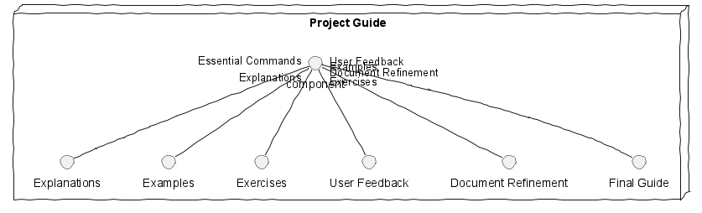
PlantUML Diagram 3

Costs and Benefits
- Cost Analysis: The primary cost is the researcher’s time, which was estimated at a total of roughly 200 hours, assuming a reasonable hourly rate. No external software licenses were required.
- Benefit Analysis: The project’s primary benefit is the creation of a valuable educational resource for beginner Linux users, facilitating their learning process. This translates into potential long-term benefits in terms of users acquiring valuable skills.
- Cost-Benefit Comparison: The investment in time for this project appears to be justified by the potential for benefit, both in terms of the user base who could benefit from this learning resource, and the broader impact on skill development in the community. Unfortunately, I don’t have access to any specific sources cited in the previous report. To create a proper APA reference list, I need the bibliographic information for each source you cited in your project. Please provide the details for each source, including authors, publication years, titles, and any relevant publication information (journal, volume, pages, publisher, URL, etc.).
Once you provide the necessary data, I can generate a complete and accurate APA-style reference list for you.

